|  |  |
| --- | --- |
| **Name** | M.Faizan Azam, Muhammad Asad |
| **Reg. #** | 2019-EE-381,2019-EE-383 |
| **Marks** |  |

Experiment # 13

# 555 Timer in Monostable and Bistable Mode

**Objectives:**

* To study the monostable mode of 555timer
* To understand the working of 555 timer in bistablemode

# Apparatus:

555 Timer, Capacitors, Resistors, DMM, CRO, Function Generator, Jumpers, Connecting wires, DC source, bread board

# Theory:

The 555 Timer is a commonly used IC designed to produce a variety of output waveforms with the addition of an external RC network. A simplified “block diagram” representing the internal circuitry of the 555 timer is given below:

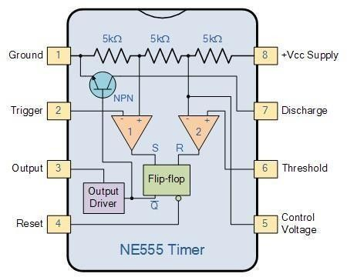

# The Monostable 555 Timer

The operation and output of the 555 timer monostable is exactly the same as that for the transistorized one we look at previously in the Monostable Multivibrators tutorial. The difference this time is that the two transistors have been replaced by the 555 timer device. Consider the 555 timer monostable circuit below.

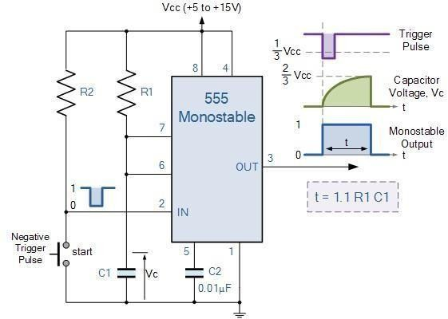

Whenanegative(0V)pulseisappliedtothetriggerinput(pin2)oftheMonostableconfigured 555 Timer oscillator, the internal comparator, (comparator No1) detects this input and “sets” thestateoftheflip-flop,changingtheoutputfroma“LOW”statetoa“HIGH”state.Thisaction in turn turns “OFF” the discharge transistor connected to pin 7, thereby removing the short circuit across the external timing capacitor,C1.

Thisactionallowsthetimingcapacitortostarttochargeupthroughresistor,R1untilthevoltage acrossthecapacitorreachesthethreshold(pin6)voltageof2/3Vccsetupbytheinternalvoltage divider network. At this point the comparators output goes “HIGH” and “resets” the flip-flop backtoitsoriginalstatewhichinturnturns“ON”thetransistoranddischargesthecapacitorto ground through pin 7. This causes the output to change its state back to the original stable “LOW” value awaiting another trigger pulse to start the timing process over again. Then as before, the Monostable Multivibrator has only “ONE” stablestate.

The Monostable 555 Timer circuit triggers on a negative-going pulse applied to pin 2 and this trigger pulse must be much shorter than the output pulse width allowing time for the timing

capacitor to charge and then discharge fully. Once triggered, the 555 Monostable will remain in this “HIGH” unstable output state until the time period set up by the R1 x C1 network has elapsed. The amount of time that the output voltage remains “HIGH” or at a logic “1” level, is given by the following time constant equation.

Where, t is in seconds, R is in Ω and C in Farads

# Bistable 555 Timer:-

Aswellastheoneshot555Monostableconfigurationabove,wecan also produce a Bistable (two stable states) device with the operation and output of the 555 Bistable being similar to the transistorised one we look at previously in the Bistable Multivibratorstutorial.

The555Bistableisoneofthesimplestcircuitswecanbuildusingthe555timeroscillatorchip. ThisbistableconfigurationdoesnotuseanyRCtimingnetworktoproduceanoutputwaveform so no equations are required to calculate the time period of the circuit. Consider the Bistable 555 Timer circuitbelow.

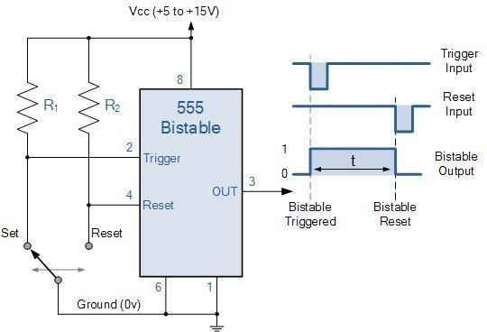

The switching of the output waveform is achieved by controlling the trigger and reset inputs of the 555 timer which are held “HIGH” by the two pull-up resistors, R1 and R2. By taking the trigger input (pin 2) “LOW”, switch in set position, changes the output state into the “HIGH” state and by taking the reset input (pin 4) “LOW”, switch in reset position, changes the output into the “LOW” state.

This 555 timer circuit will remain in either state indefinitely and is therefore bistable. Then the Bistable 555 timer is stable in both states, “HIGH” and “LOW”. The threshold input (pin 6) is connectedtogroundtoensurethatitcannotresetthebistablecircuitasitwouldinanormaltiming application.

# Design:

Design and show the working of 555 timer in Monostable & Bistable mode.

# Monostablemode: Circuit:

**Input Waveform:**

**Output Waveform:**

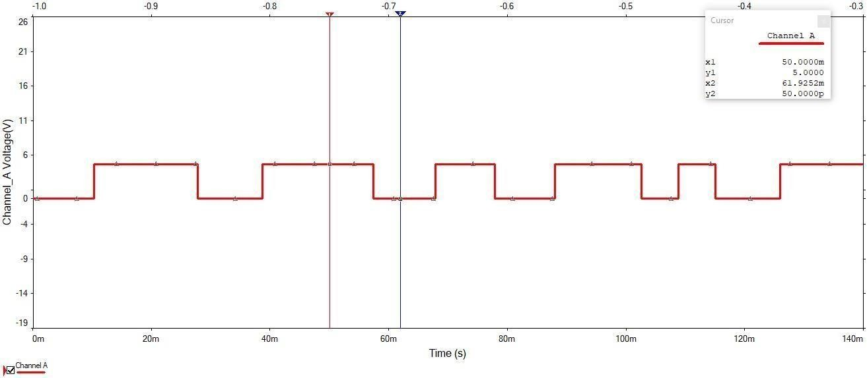

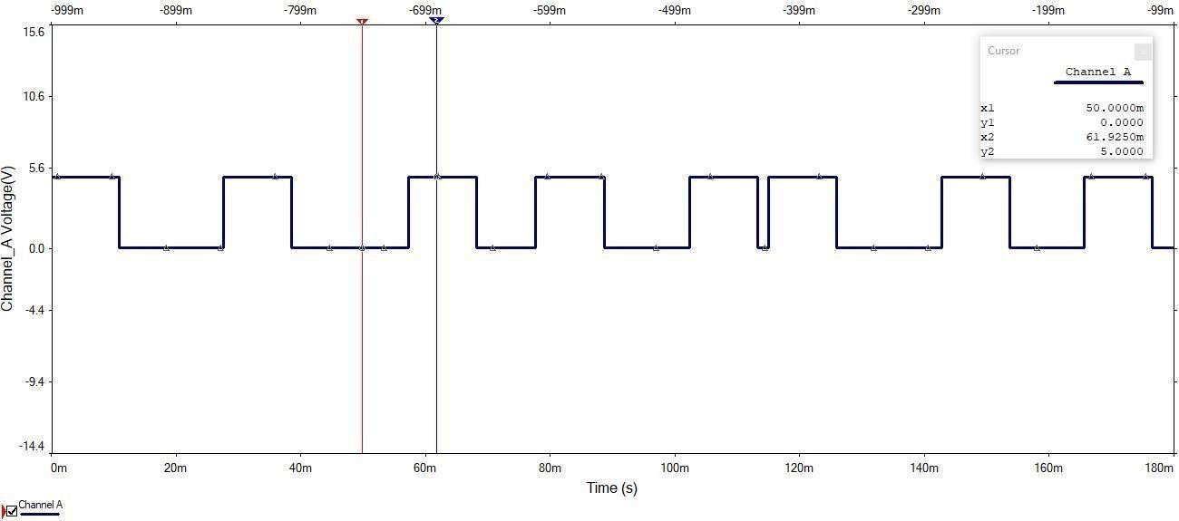

1. **BistableMode:**

**Circuit:**

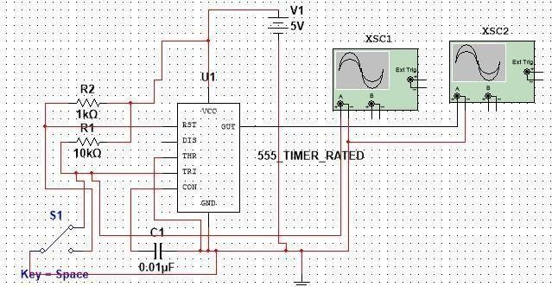

**Input Waveform:**

